1 run......

Downloading: 100%

411/411 [00:00<00:00, 14.7kB/s]

Downloading: 100%

263M/263M [00:06<00:00, 41.9MB/s]

training 1 epoch...

137.95836758613586 seconds used......

1 training finished! average train loss: 0.8653761573618997

evaluating...

Confusion matrix, without normalization

[[ 0 7 117]

[ 0 28 136]

[ 0 16 849]]

Normalized confusion matrix

[[0. 0.05645161 0.94354839]

[0. 0.17073171 0.82926829]

[0. 0.01849711 0.98150289]]

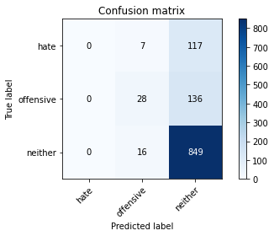

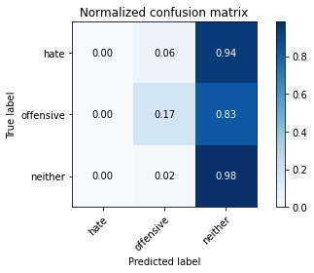

/opt/conda/lib/python3.7/site-packages/sklearn/metrics/_classification.py:1245: UndefinedMetricWarning: Precision and F-score are ill-defined and being set to 0.0 in labels with no predicted samples. Use `zero_division` parameter to control this behavior.

_warn_prf(average, modifier, msg_start, len(result))

/opt/conda/lib/python3.7/site-packages/sklearn/metrics/_classification.py:1245: UndefinedMetricWarning: Precision and F-score are ill-defined and being set to 0.0 in labels with no predicted samples. Use `zero_division` parameter to control this behavior.

_warn_prf(average, modifier, msg_start, len(result))

/opt/conda/lib/python3.7/site-packages/sklearn/metrics/_classification.py:1245: UndefinedMetricWarning: Precision and F-score are ill-defined and being set to 0.0 in labels with no predicted samples. Use `zero_division` parameter to control this behavior.

_warn_prf(average, modifier, msg_start, len(result))

precision recall f1-score support

hate 0.00 0.00 0.00 124

offensive 0.55 0.17 0.26 164

neither 0.77 0.98 0.86 865

accuracy 0.76 1153

macro avg 0.44 0.38 0.37 1153

weighted avg 0.66 0.76 0.68 1153

average eval_loss: 0.6793668357462719, accuracy: 0.7606244579358196

training 2 epoch...

137.09332656860352 seconds used......

2 training finished! average train loss: 0.7695751943889332

evaluating...

Confusion matrix, without normalization

[[ 43 30 51]

[ 30 70 64]

[107 60 698]]

Normalized confusion matrix

[[0.34677419 0.24193548 0.41129032]

[0.18292683 0.42682927 0.3902439 ]

[0.12369942 0.06936416 0.80693642]]

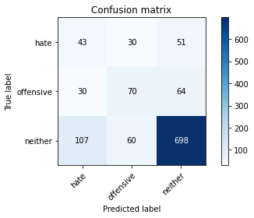

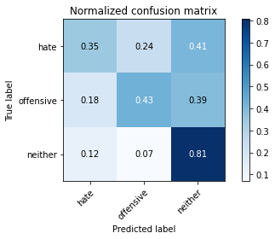

precision recall f1-score support

hate 0.24 0.35 0.28 124

offensive 0.44 0.43 0.43 164

neither 0.86 0.81 0.83 865

accuracy 0.70 1153

macro avg 0.51 0.53 0.52 1153

weighted avg 0.73 0.70 0.72 1153

average eval_loss: 0.7471607866986044, accuracy: 0.7033824804856895

training 3 epoch...

137.11258149147034 seconds used......

3 training finished! average train loss: 0.6273811027255075

evaluating...

Confusion matrix, without normalization

[[ 28 30 66]

[ 16 57 91]

[ 63 49 753]]

Normalized confusion matrix

[[0.22580645 0.24193548 0.53225806]

[0.09756098 0.34756098 0.55487805]

[0.07283237 0.0566474 0.87052023]]

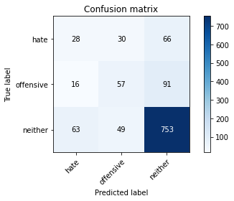

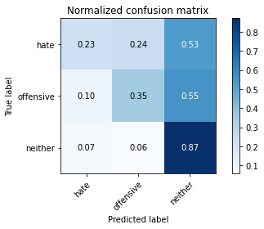

precision recall f1-score support

hate 0.26 0.23 0.24 124

offensive 0.42 0.35 0.38 164

neither 0.83 0.87 0.85 865

accuracy 0.73 1153

macro avg 0.50 0.48 0.49 1153

weighted avg 0.71 0.73 0.72 1153

average eval_loss: 0.7070000402886292, accuracy: 0.7267996530789246

training 4 epoch...

137.2154541015625 seconds used......

4 training finished! average train loss: 0.38509129661647123

evaluating...

Confusion matrix, without normalization

[[ 59 20 45]

[ 48 59 57]

[184 35 646]]

Normalized confusion matrix

[[0.47580645 0.16129032 0.36290323]

[0.29268293 0.3597561 0.34756098]

[0.21271676 0.04046243 0.74682081]]

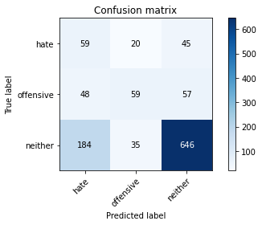

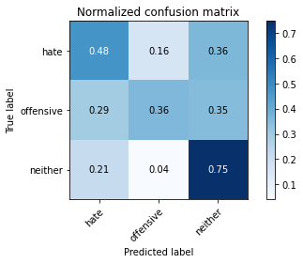

precision recall f1-score support

hate 0.20 0.48 0.28 124

offensive 0.52 0.36 0.42 164

neither 0.86 0.75 0.80 865

accuracy 0.66 1153

macro avg 0.53 0.53 0.50 1153

weighted avg 0.74 0.66 0.69 1153

average eval_loss: 0.994978538361089, accuracy: 0.6626192541196878

training 5 epoch...

137.05121278762817 seconds used......

5 training finished! average train loss: 0.19512533960361733

evaluating...

Confusion matrix, without normalization

[[ 54 29 41]

[ 39 69 56]

[229 77 559]]

Normalized confusion matrix

[[0.43548387 0.23387097 0.33064516]

[0.23780488 0.42073171 0.34146341]

[0.26473988 0.08901734 0.64624277]]

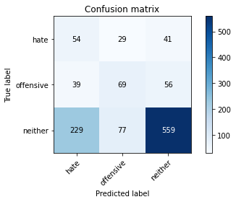

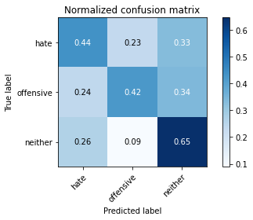

precision recall f1-score support

hate 0.17 0.44 0.24 124

offensive 0.39 0.42 0.41 164

neither 0.85 0.65 0.74 865

accuracy 0.59 1153

macro avg 0.47 0.50 0.46 1153

weighted avg 0.71 0.59 0.64 1153

average eval_loss: 1.3469134291698193, accuracy: 0.5915004336513443

2 run......

training 1 epoch...